

**TOPIC: To Supply Leftover Food to Poor**

**NM ID: 0 9 2 0 9 F 3 A 3 5 8 1 1 D 7 B A 9 F 4 0 F C 5 F 3 2 A 2 4 1 4**

**TEAM DETAILS:**

* **Team Lead: Srimathi.M**

**---E-mail:** [**23bsct262srimathim@skacas.ac.in**](mailto:23bsct262srimathim@skacas.ac.in)

**---Reg-no: 2326k0352**

* **Team member 1: Anisha Fathima.A**

**---E-mail:**[**23bsct267anishafathimaa@skacas.ac.in**](mailto:23bsct267anishafathimaa@skacas.ac.in)

**---Reg-no: 2326j6001**

* **Team member 2: Shanmugapriya.S**

**---E-mail:** [**23bsct260shanmugapriyas@skacas.ac.in**](mailto:23bsct260shanmugapriyas@skacas.ac.in)

**---Reg-no: 2326k0350**

* **Team member 3: Sathyapriya.S**

**---E-mail:** [**23bsct259sathiyapriyas@skacas.ac.in**](mailto:23bsct259sathiyapriyas@skacas.ac.in)

**---Reg-no: 2326k0349**

# Project Overview

FoodConnect is a transformative initiative that tackles two pressing global issu es: food waste and hunger. By leveraging cuttingedge Salesforce technology, we aim to connect surplus food from restaurants, grocery stores, events, and households with underprivileged communities in need of nourishment.

Our vision is simple yet impactful: to create a seamless system that ensures left over food is not wasted but instead redistributed efficiently to those who nee d it most. With Salesforce as our backbone, FoodConnect will streamline food collection, optimize volunteer coordination, and ensure timely delivery to desi gnated dropoff points.Through realtime tracking, intelligent task allocation, an d insightful reporting, FoodConnect will foster transparency and accountability across the entire process. Volunteers will find it easier to engage, donors will have confidence in the system, and recipients will benefit from reliable access to food.This project isn’t just about logisticsit’s about building a culture of shar ing, reducing environmental impact, and creating a replicable model for other communities. By bridging the gap between surplus and scarcity, FoodConnecta spires to make a meaningful difference, one meal at a time

# Objectives

At the heart of FoodConnect lies a mission to address food waste and hunger while empowering communities through efficient technology. Our objectives a re crafted to deliver measurable impact and foster a culture of sharing and acc ountability.

# Business Goals:

* 1. **Reduce Food Waste**: Redirect surplus food from donors such as restaura nts, grocery stores, and events to those in need, minimizing wastage an d maximizing its value.
  2. **Combat Hunger**: Build a reliable network that connects food suppliers wi th nonprofits,shelters, and underserved communities, ensuring timely ac cess to nutritious meals.
  3. Streamline Operations: Simplify and enhance volunteer coordination, tas k management, and communication to create a seamless experience for all stakeholders.
  4. Promote Transparency and Accountability: Leverage technology to provi de clear tracking, reporting, and insights into food collection, distributio n, and impact.

**Specific Outcomes:**

#### A Comprehensive Web Application:

* + Manage venues and drop-off points efficiently.
  + Enable real-time task assignment and tracking for volunteers.
  + Provide robust reporting and analytics dashboards to measure perfor mance and impact.

#### Intelligent Automation:

* + Automate the matching of food donations based on location, food type, and urgency to optimize logistics and reduce delays.

#### Enhanced Communication and Collaboration:

* + Foster realtime updates and coordination among donors, volunteers, and recipients through integrated communication tools.

#### Data-Driven Insights:

* + Generate actionable insights to continuously improve operations, measu re impact, and refine strategies for food redistribution.

# Salesforce Key Features and Concepts Utilized

FoodConnect leverages the power of Salesforce to create an efficient

, userfriendly platform that streamlines food redistribution and volun teer management. Here’s how we’ve utilized Salesforce features to bring this initiative to life.

1. **Venues**: Store vital information about food donation locations, including add ress, capacity, and contact details, ensuring organized management of distribu tion points.

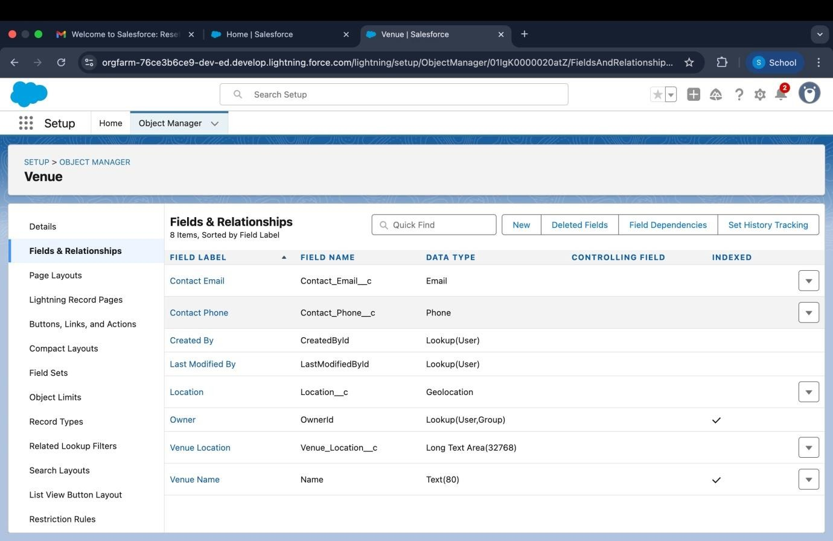

1. **DropOff Points**: Record specific delivery locations, making it easier for volunt eers to plan and execute tasks effectively.

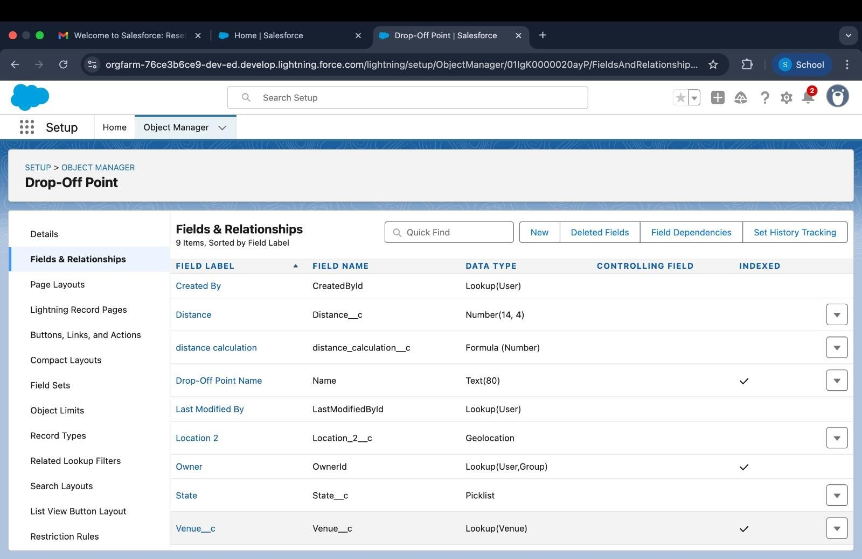

1. **Tasks**: Track and manage volunteer assignments with fields for descriptions, deadlines, and responsible individuals.

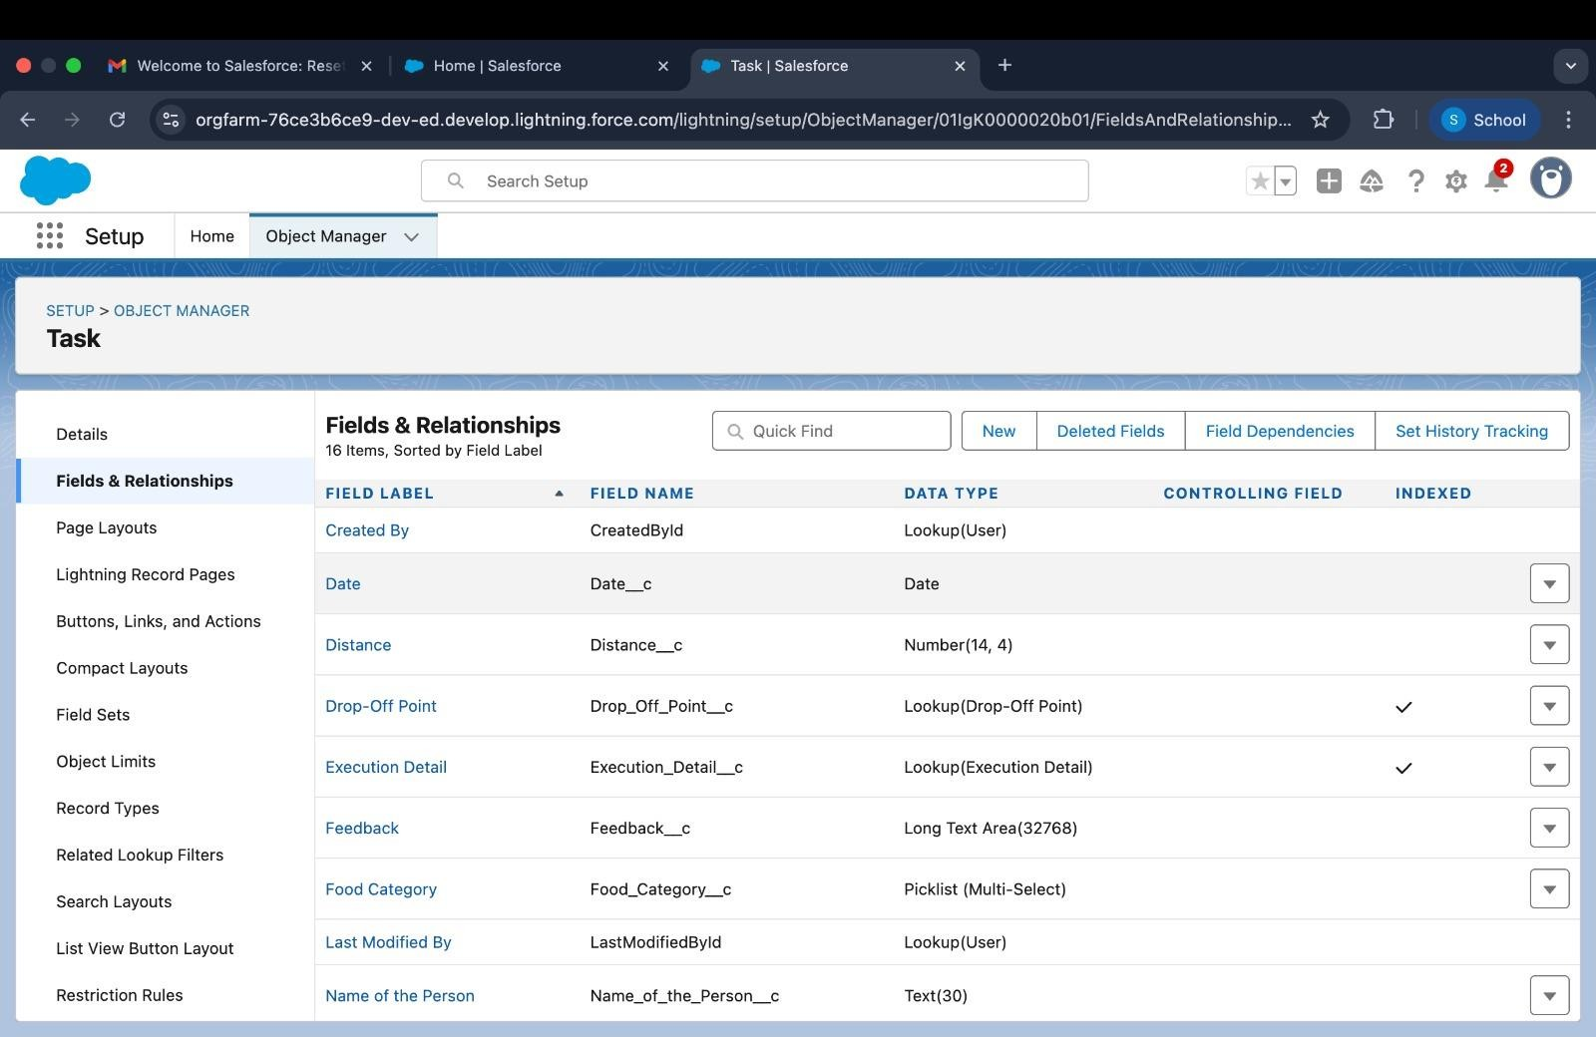

1. **Volunteers**: Maintain a centralized database of volunteers, including their co ntact details, availability, and assigned tasks.

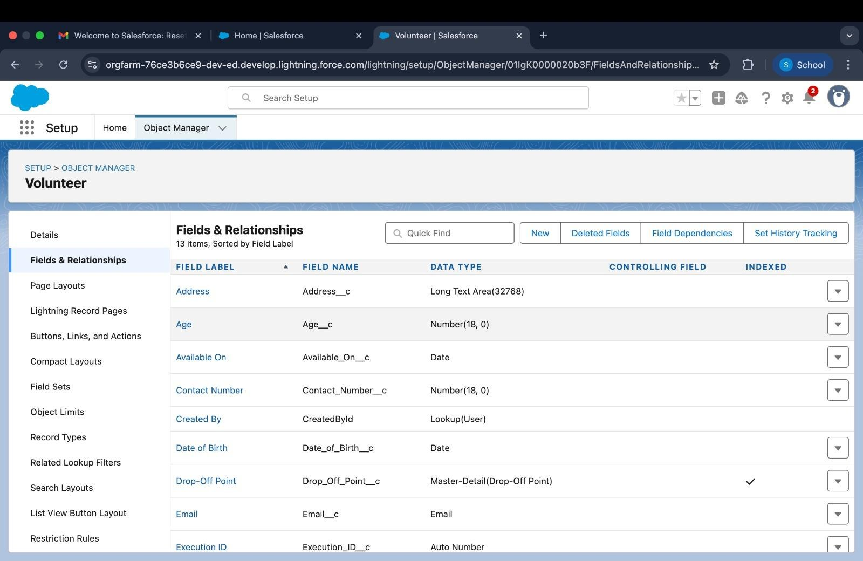

1. **Execution Details**: Document completed tasks, linking them to specific volunt eers and drop-off points for a detailed activity history.

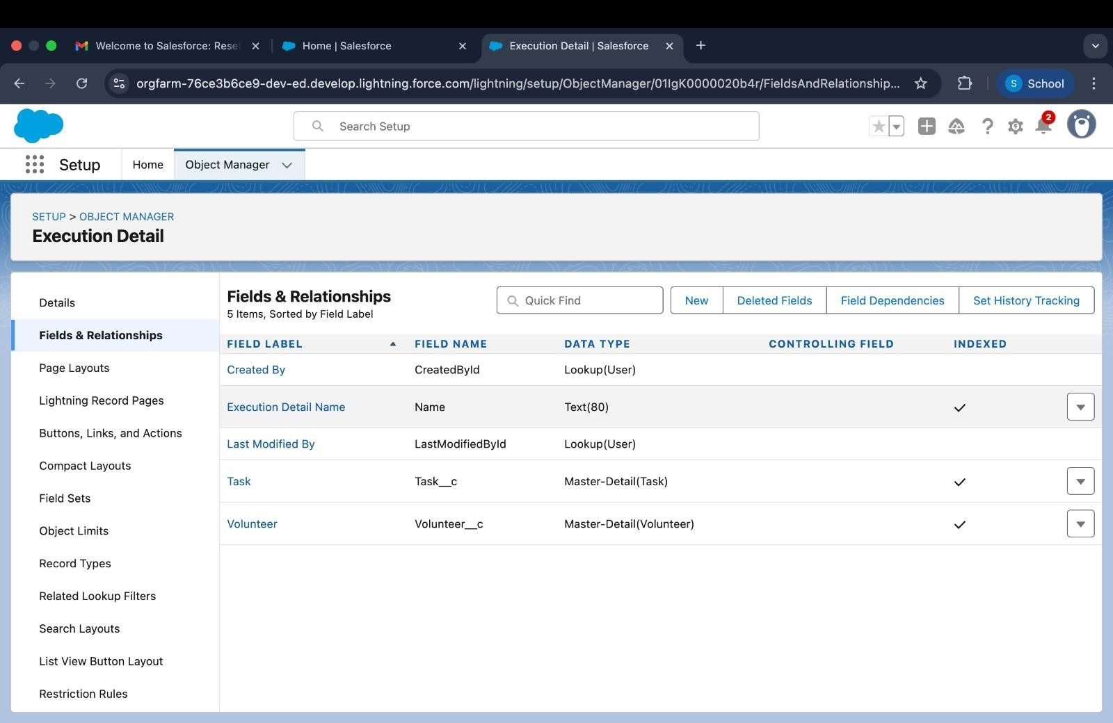

# Relationships

* + **MasterDetail Relationships**: Create structured connections, such as linki ng tasks to their execution details, ensuring data consistency and logical organization
  + **Lookup Relationships**: Enable flexible associations, like connecting volun teers to dropoff points, allowing for dynamic task allocation based on lo cation and availability

## Automations and Workflows

1. **Flows**: Automate processes like creating venue records or assigning tasks, gui ding users through step-by-step workflows to ensure accuracy and efficiency.

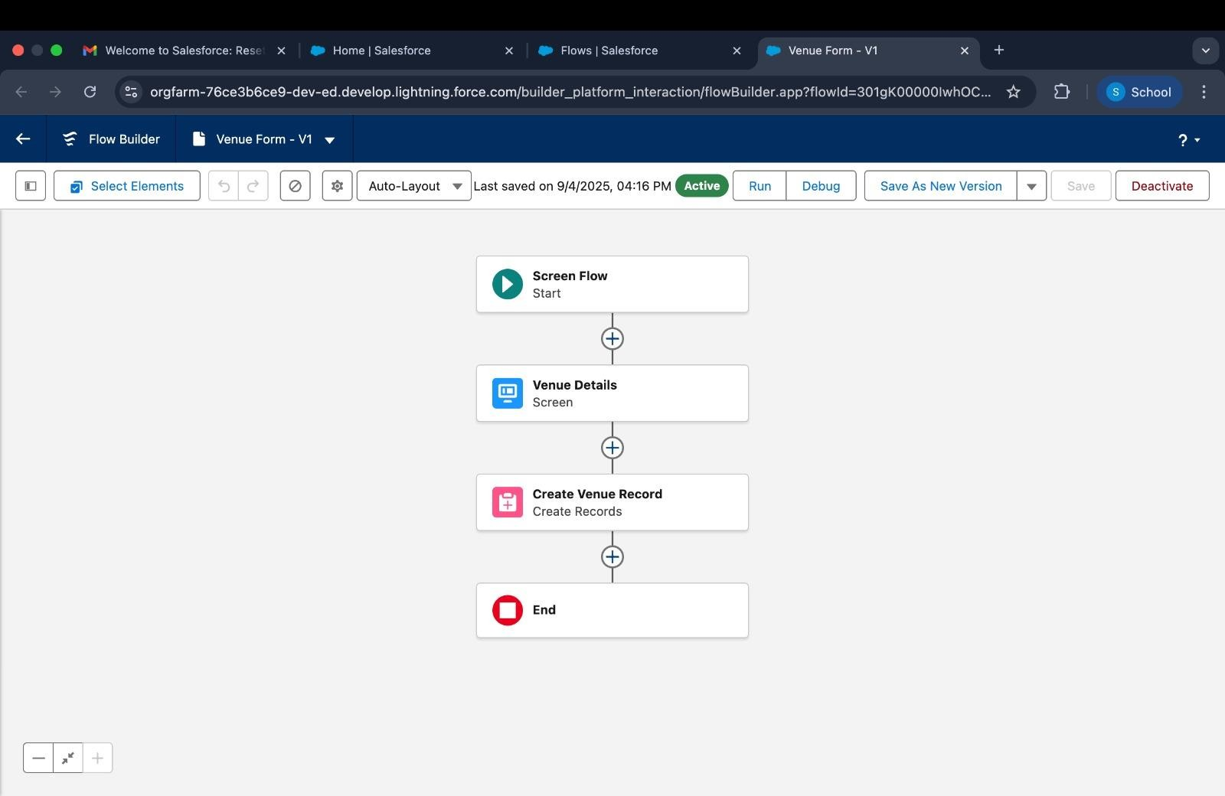

1. **Apex Triggers**: Implement custom logic, such as calculating distances betwee n venues and volunteers, to optimize task assignments and reduce delivery ti mes.

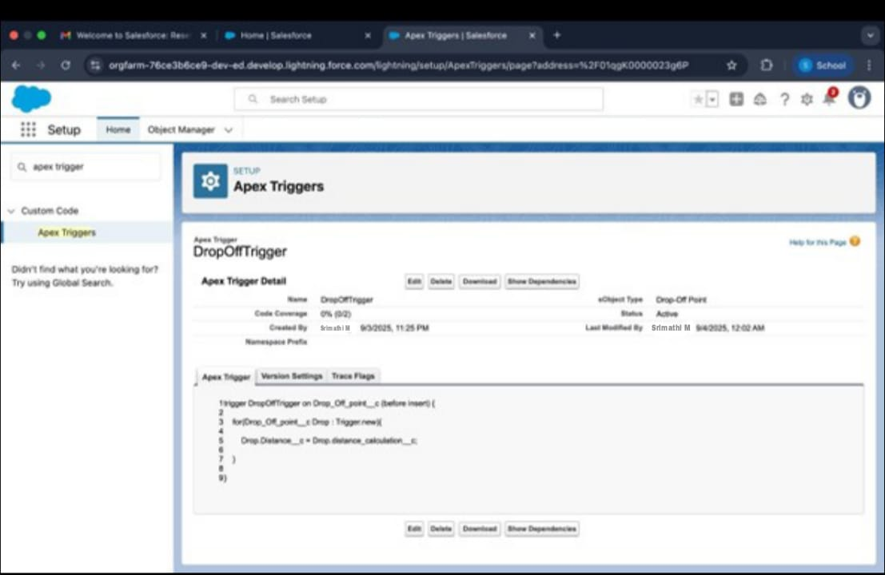

## Data Sharing and Security

* + **Profiles and Roles**: Define user roles with tailored access levels to protect sensitive data while ensuring seamless collaboration.

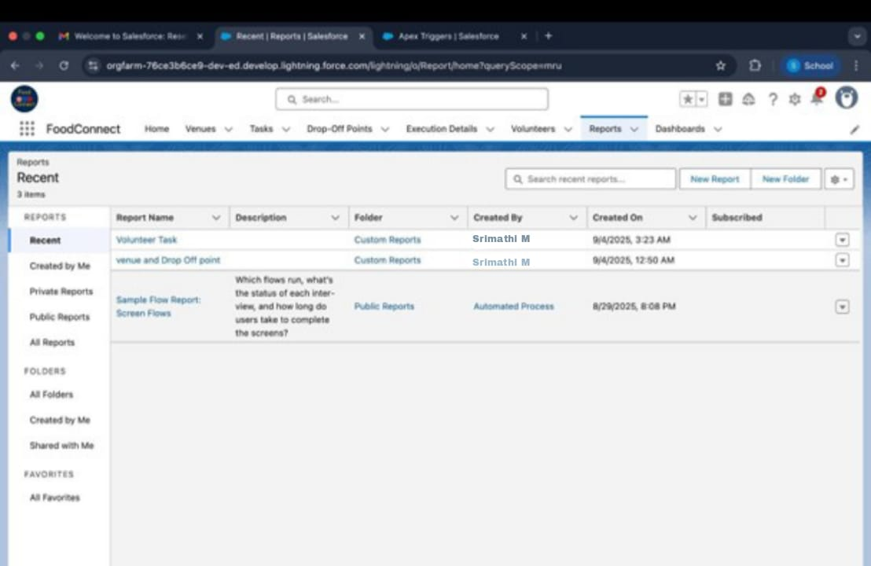

* + **Dashboards**: Provide visual representations of key data, empowering stake holders to make informed decisions and track progress in real-time.

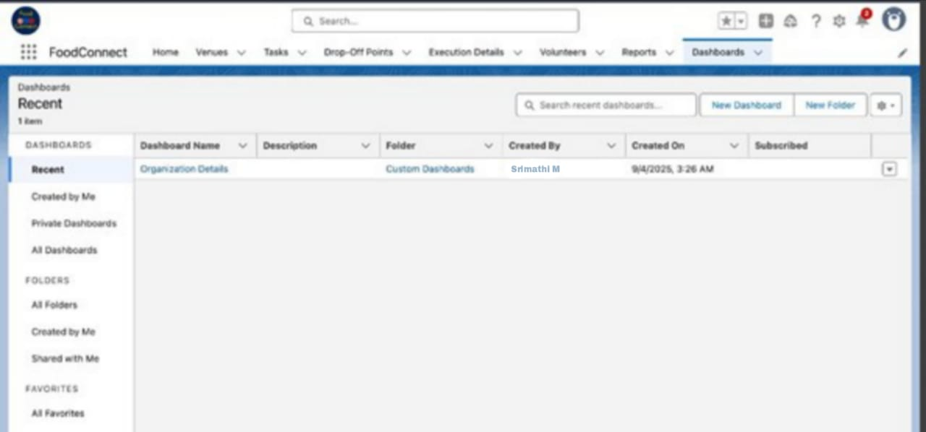

## User Experience Enhancements

* + **Lightning App**: Deliver a sleek, intuitive interface that simplifies navigation and ensures users can quickly access essential features.

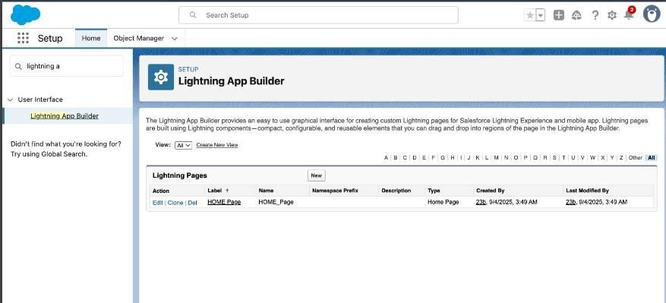

* + Automated Notifications: Keep stakeholders informed with realtime alerts a bout task updates, food collection schedules, and delivery statuses.

1. **Detailed Steps to Solution Design**

Building FoodConnect involved a structured and thoughtful approach to ensure the platform meets the needs of donors, volunteers, and recipients while leve raging the robust capabilities of Salesforce. Below is a step-by-step breakdown of the design and implementation process:

### Step 1: Developer Account Setup

* Registered for a Salesforce Developer account to create a dedicated environ ment for development and testing.
* Verified the account to unlock full access to Salesforce features, ensuring a smooth setup process.

### Step 2: Custom Object Creation

* + Used Salesforce Object Manager to design custom objects for Venues, Dr op-Off Points, Tasks, Volunteers, and Execution Details.
  + Configured fields such as text, numbers, dates, and relationships to capt ure all relevant data, ensuring each object reflects the real-

world requirements of food distribution logistics.

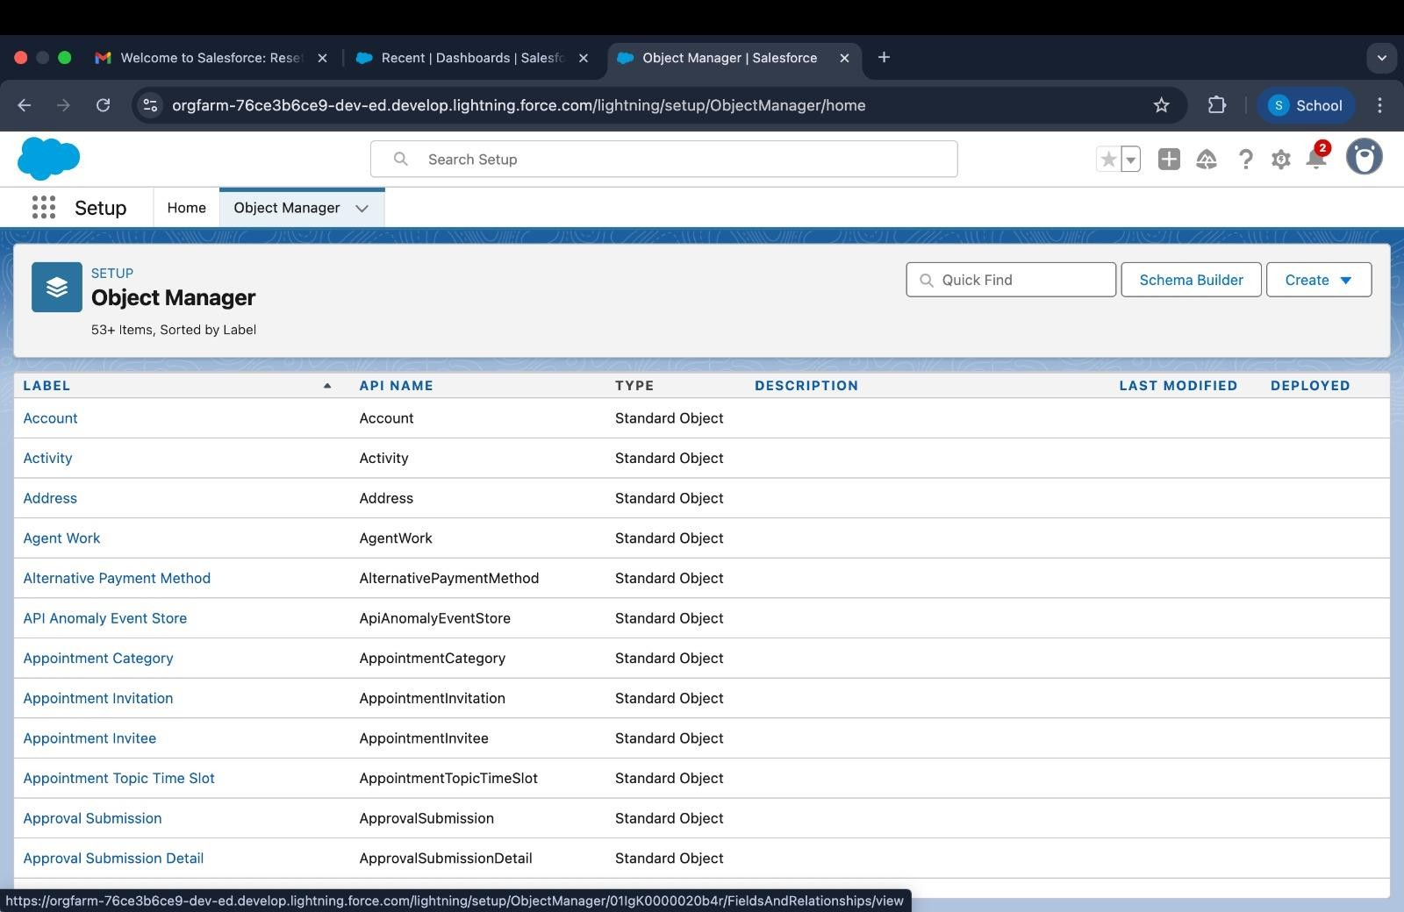

### Step 3: Custom Tabs for Navigation

* + Created custom tabs for each object, improving navigation and making it easier for users to access and manage data.

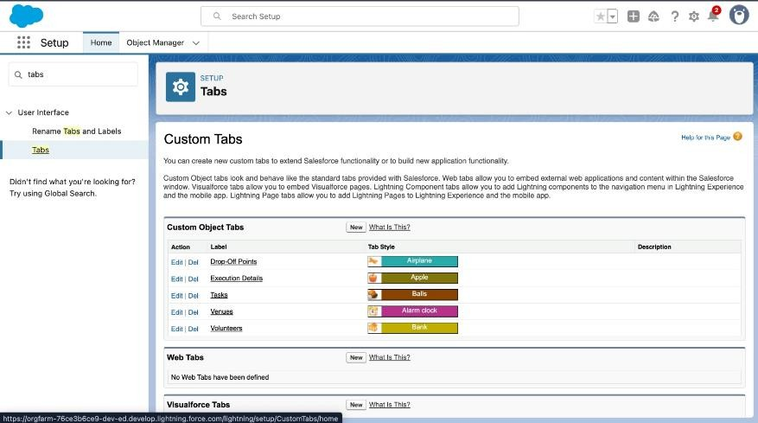

### Step 4: Lightning App Development

* + Developed a Lightning App named "FoodConnect" using Salesforce App Manager.
  + Included essential navigation items like custom objects, reports, and das hboards to provide a user-friendly interface.
  + Assigned user profiles to ensure role-based access and security

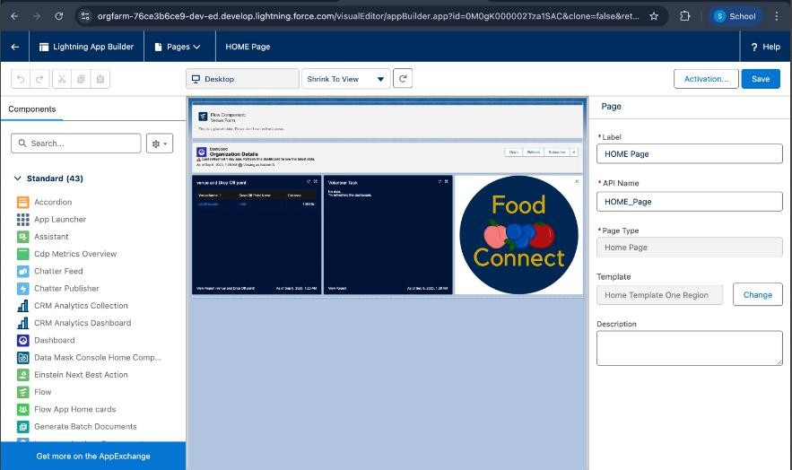

### Step 5: Establishing Data Relationships

* Defined relationships between objects using MasterDetail and Lookup fields For example:
* MasterDetail between Tasks and Execution Details to track completed activities.
* Lookup between Volunteers and Drop- Off Points to assign tasks efficiently

### Step 6: Field Configuration

* Configured fields for each custom object to capture data accurately. For instance:
* Venue: Name, Address, Capacity, Contact Information.
* Tasks: Description, Due Date, Assigned Volunteer.
* Volunteers: Contact Details, Availability.

### Step 7: Flow Design

* + Designed a guided screen flow to simplify the process of entering Venue information.
  + Automated record creation to ensure data accuracy and reduce manual errors.

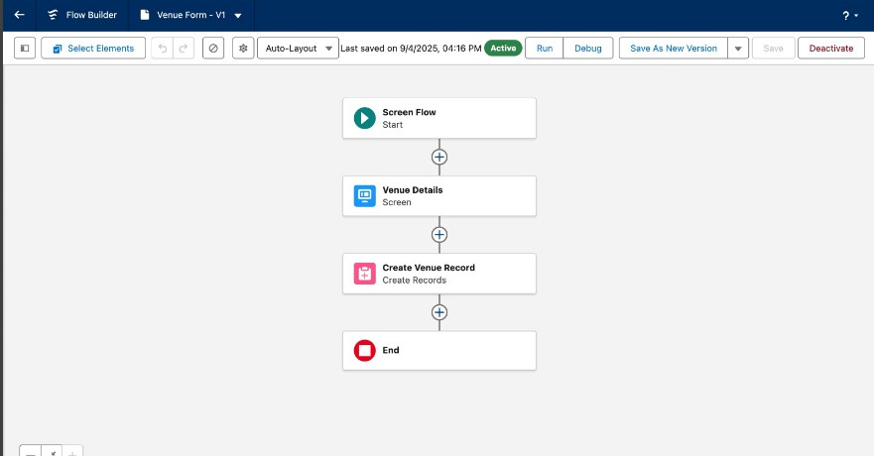

### Step 8: Trigger Implementation

* + Developed Apex triggers to enhance automation, such as calculating dist ances between venues and volunteers.
  + These triggers help assign tasks based on proximity, improving logistical efficiency.



### Step 9: User Management and Permissions

* Set up user profiles for administrators, volunteers, and other stakeholders.
* Configured permissions to ensure secure and role-appropriate access to data and functionalities.

### Step 10: Reporting and Dashboards

* Created custom report types to analyze key metrics, such as volunteer participation, task completion rates, and food distribution impact.
* Built interactive dashboards to visualize data trends and provide actionable insights, empowering stakeholders to make informed decisions.

## Testing and Validation

To ensure the FoodConnect solution functions seamlessly and meets all project requirements, a thorough testing and validation process was implemented.

This approach focused on verifying both the technical and user-facing aspects of the system.

### Unit Testing

* + **Objective**: Validate the functionality of individual components, such as A pex triggers, workflows, and custom objects.

#### Actions:

* + - Tested forms for venues, tasks, and drop-off points to ensure Accurate data capture and validation.
    - Verified data storage and retrieval processes for volunteers, ensuring that all records were consistent and error-free.
    - Confirmed the proper execution of automated calculations, such as distance-based task assignments.

#### User Interface Testing

* + **Objective**: Ensure the system is intuitive and user-friendly for all stake holders, including donors, volunteers, and administrators.

#### Actions:

* + - Conducted extensive testing across all pages to confirm responsive d esign and seamless navigation.
    - Verified that reports and dashboards displayed accurate and up-to- date data in an easily interpretable format.
    - Ensured compatibility across various devices, with a focus on mobile accessibility for field agents.

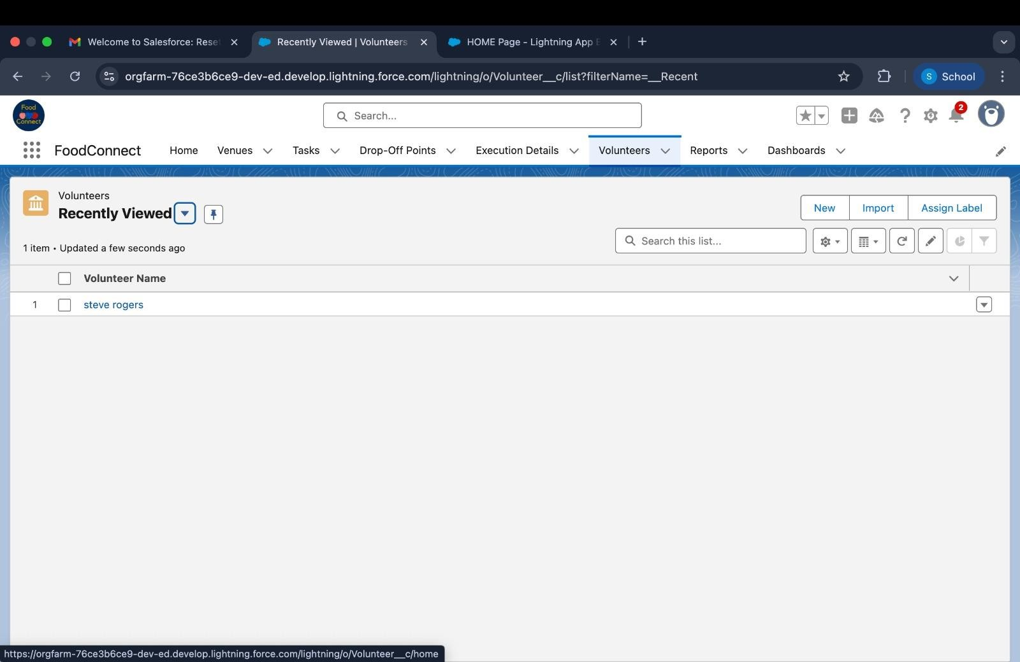



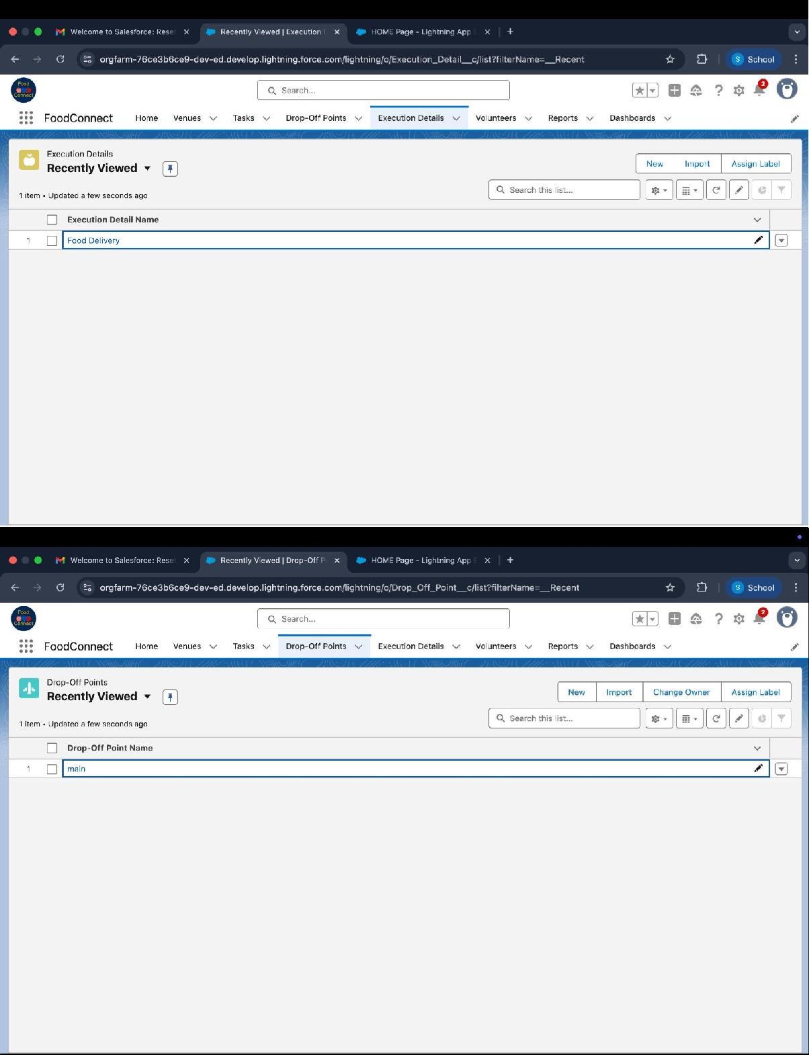

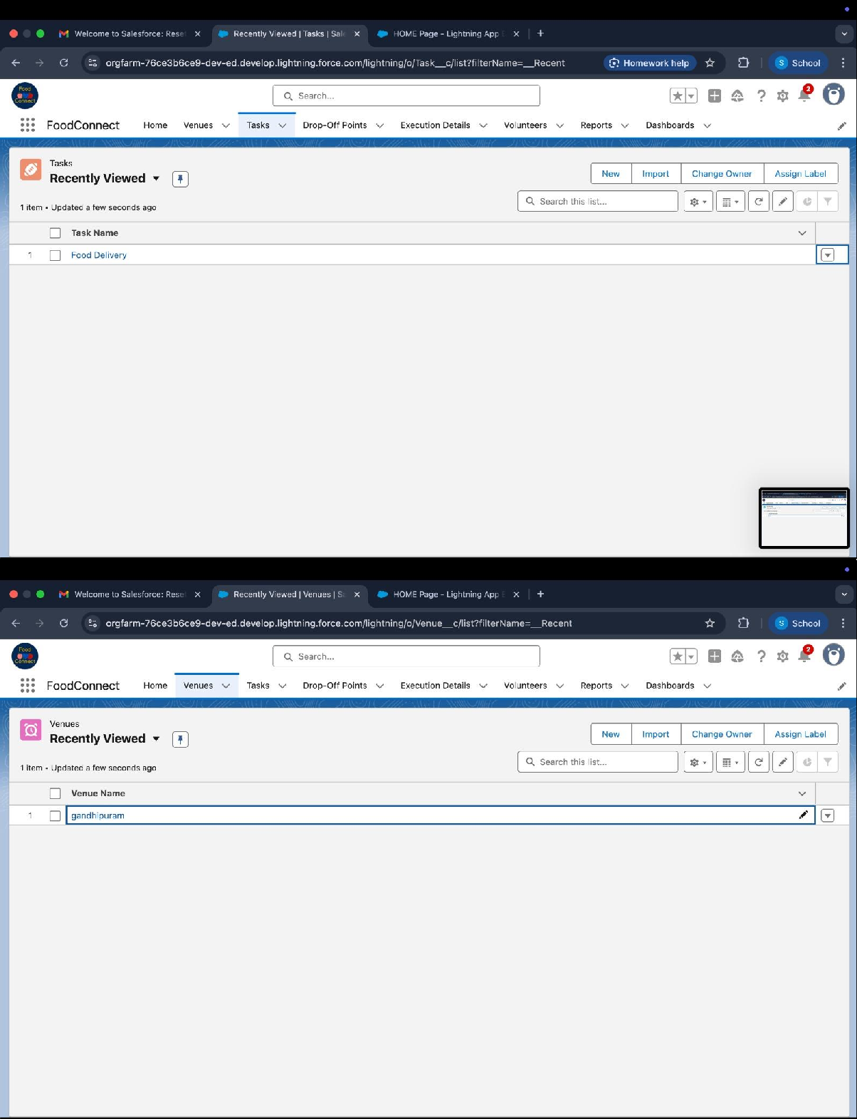

### Key Scenarios Addressed by Salesforce in the Implementation Project

The FoodConnect project leverages Salesforce's capabilities to address a variety of realworld scenarios, ensuring efficient. Below are the key scenarios tackled during the implementation: Salesforce can handle during the

implementation.

### Efficient Management of Food Donation Venues

* + Scenario: A donor provides surplus food, and the details of the donation venue need to be recorded accurately.
  + Salesforce Solution: Custom objects and fields were created to capture c ritical venue details, including name, address, capacity, and contact info rmation, ensuring seamless record-keeping and accessibility.

### Task Assignment and Tracking for Volunteers

* + Scenario: Volunteers need to be assigned tasks based on their availabilit y and proximity to venues or drop-off points.
  + Salesforce Solution: Using Master-Detail relationships and Apex triggers, tasks are automatically assigned to the most suitable volunteers, and progress is tracked in real-time through the Tasks object.

### Coordination of Food Drop-Off Points

* + Scenario: Food needs to be delivered to designated drop-off points efficiently and reliably.
  + Salesforce Solution: Drop-Off Points were managed as a custom object, with detailed fields for location, capacity, and operational hours, enabling smooth coordination and tracking.

### Volunteer Engagement and Management

* + Scenario: Volunteers need to view their assignments, update their availa bility, and track their contributions.
  + Salesforce Solution: A Volunteers object with a user-friendly interface Allows volunteers to manage their profiles and view task details, Enhancing engagement and retention.

### Real-Time Communication and Notifications

* + Scenario: Stakeholders require updates on task assignments, delivery sch edules, or any changes in plans.
  + Salesforce Solution: Automated workflows and notifications ensure that all participants are informed promptly, reducing delays and misundersta ndings.

### Data Integrity and Reporting

* + Scenario: Stakeholders need to analyze the impact of food distribution ef forts and identify areas for improvement.
  + Salesforce Solution: Custom report types and dashboards provide action able insights into task completion rates, volunteer participation, and foo d distribution metrics, ensuring data-driven decision-making.

### Automation of Logistical Calculations

* + Scenario: Volunteers need to be assigned to venues or drop-off points based on proximity to minimize travel time and enhance efficiency.
  + Salesforce Solution: Apex triggers calculate distances between venues and volunteers, automating task assignments and optimizing logistics.

### Secure and Role-Based Data Access

* + Scenario: Different stakeholders require access to specific information based on their roles.
  + Salesforce Solution: Profiles, sharing rules, and public groups ensure that users only access data relevant to their roles, maintaining security and confidentiality.

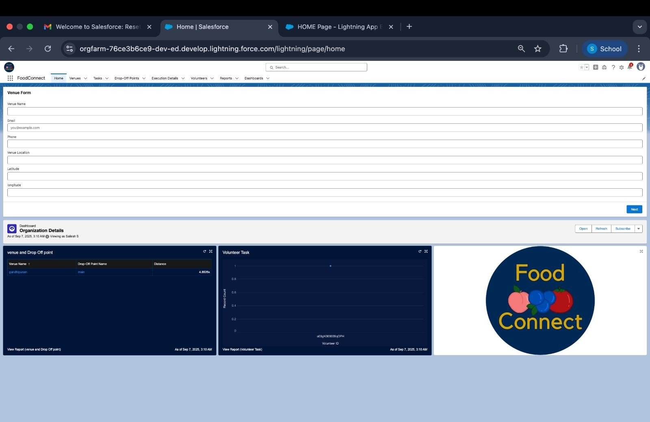

## Conclusion

#### Summary of Achievements:

The FoodConnect project successfully delivered a comprehensive solution to address food waste and hunger by leveraging the power of Salesforce tech nology. Key accomplishments include:

* + **Streamlined Food Distribution**: Developed a robust system to manage the collection, allocation, and delivery of surplus food to underserved communi ties.
  + **Enhanced Volunteer Management**: Implemented efficient task assignment and tracking mechanisms to optimize volunteer engagement and contributi ons.
  + **DataDriven Insights**: Created detailed reports and dashboards, providing a ctionable insights into food redistribution metrics, volunteer participation, a nd overall impact.
  + **UserFriendly Interface**: Designed an intuitive Lightning App, ensuring a sea mless experience for all users, including donors, volunteers, and administra tors.
  + **Operational Efficiency**: Automated workflows and triggers to reduce manua l effort, improve accuracy, and ensure timely execution of tasks.

